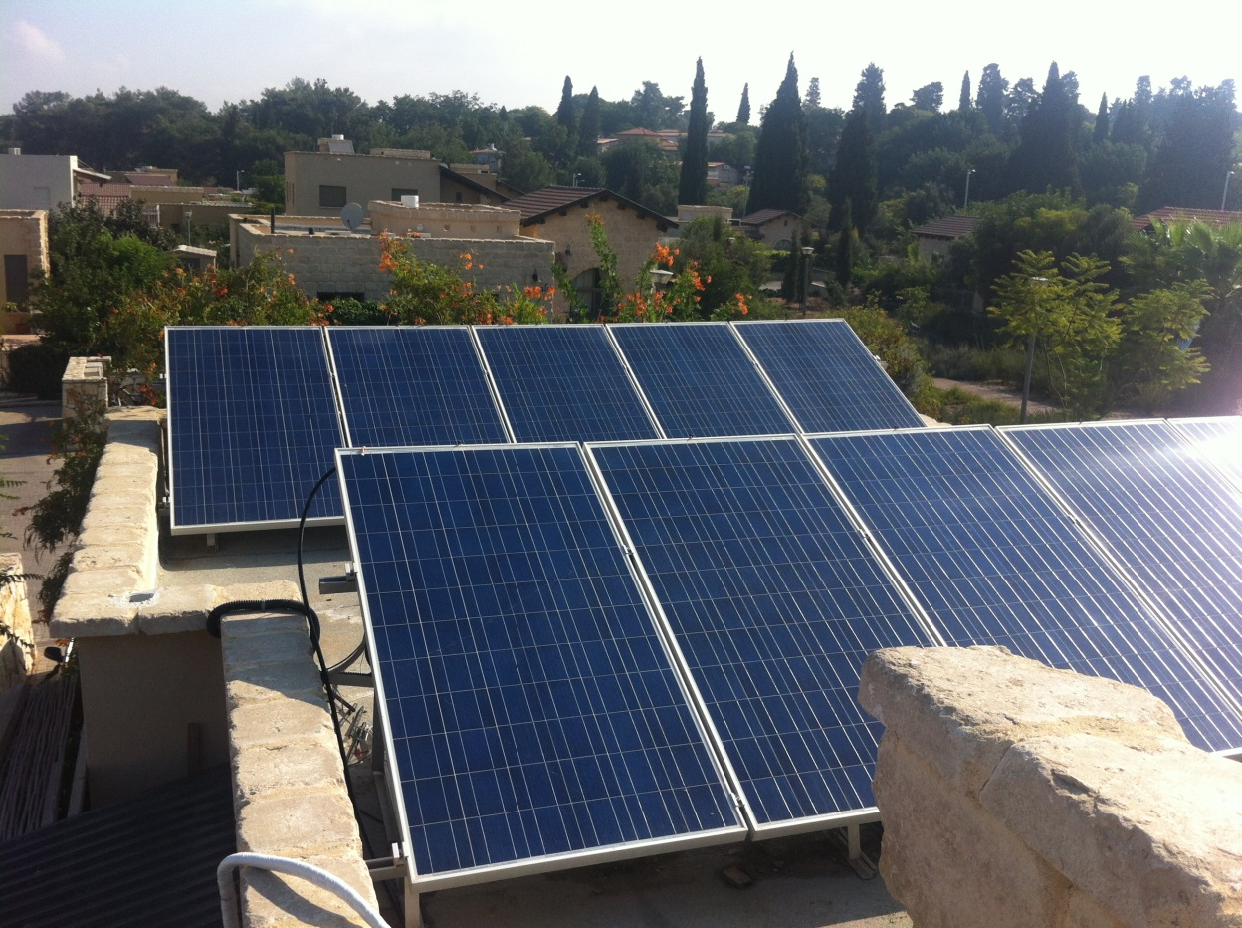



PVCooler

PVCooler was installed on a rooftop PV system.

Two independent strings of 3KW each were used. One string had PVCooler installed and the other was used as a reference. Each string shows output via a separate SMA inverter. The microcontroller displays continuous PV Panel temperature and radiation

Production Gain results

COMPANY

**Features Include:**

Water Filtering unit

Pump

Microcontroller

Heat and radiation sensors

Sprinklering system

www.pvcooler.com

**PVCooler Prototype**

**SALE**

For

